- Orientation to the Parent School Support Committee
- Electing a Chair, Vice-Chair and Secretary for the school year
- Reviewing the School Improvement Plan and the Positive Learning and Working Environment Plan in detail over the course of several meetings
- Reviewing School Based Global and Fundraising budgets as well as managing the assigned PSSC Global Budget
- Reviewing staff changes and understanding the parameters surrounding the many changes that occur from year to year
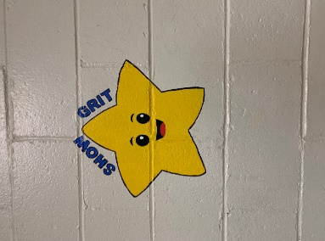
- Reviewing enrolment data, bus data, Provincial Assessment data, Wellness Survey data each year. Discussing trends, patterns, differences noted, etc.
- Asking questions and advocating for the community of learners
- Learning about the School Messenger Communication System
- Corresponding with the Minister of Education and Early Childhood Development surrounding legislation that is linked to PSSC elections
- Learning about Right to Information and Protection of Privacy obligations
Showing interest in improving and supporting the school nutrition programs
- Helping to develop the Parent Survey sent to families annually in Feb./March
- Advocating for a new sidewalk adjacent to Ellerslie Street by meeting with the Mayor and Chief Administrative Officer for the Town of Oromocto
- Reviewing ways in how to best engage parents
- Supporting “Staff Appreciation Week”
- Working with District Education Council member representing the Town of Oromocto schools and DEC Chair (Sub-district 13, Thomas Geburt)
- Participation in the hiring of an acting vice-principal for 2021-2022 (Sheila Morgan)
- Reviewing monthly news relevant to Summerhill and published in the newsletters
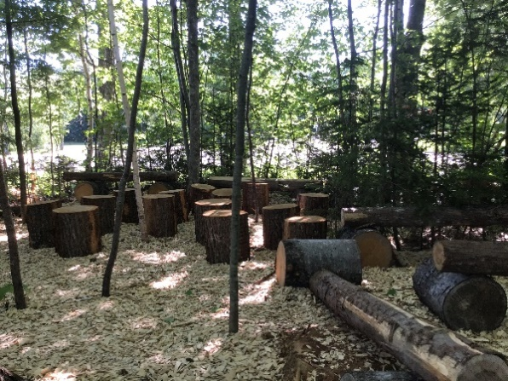
- Supporting the Outdoor Beautification projects/Indoor positive messages on Wall
- Paid for Dr. Norma St. Croix to provide 2 presentations (one to our staff and one to our parents). The information provided will help further our Literacy Goal in the School Improvement Plan.

